Manual

I - Getting started

Overview
ZebraSound is a tool to sonify neural imaging data. It uses a system of regions of interest (ROI) on which parameters are computed then used to control the outcoming sound. Currently up to 200 ROIs can be used at the same time.
The principle of the sonification is to let each ROI play a single note, which amplitude is mapped to the mean value of the ROI (« Signal ») at the current frame. The ROIs are put in groups, defined by their color and number, each ROIs in a given group play the same note. The allocations of the groups, and associated notes notes is left to the user, and another group related parameter (mean value, etc) can be mapped to the brightness of the sound.
The data used for the sonification are the mean values on each ROIs over time computed with FIJI and treated with the provided Matlab scripts, and the ROI set from FIJI treated with the matlab script.
Thus the patcher requires :
- The data
- The ROIs locations
- The notes attributed to each group
- The video associated with the data
You can freely allocate ROIs to up to nine groups, set notes for the groups, change and save the mapping, and select the sound produced by the different groups.
To lauch the program, double click on zebraSound.maxproj. At the start, the program loads a default set of data with the associated groups.

Installation
The software runs with Max/MSP (Cycling `74) and can be downloaded here. Max/MSP is a commercial software, however a trial version allows you to run patchers and to save changes for up to 31 days.
To install the sofware unzip the .zip file in a new folder. It contains all the files needed to lauch the program.
The other folder contains the scripts needed to treat the data in order to use them with Max/MSP. There are three scrpts : exportClusters.m (cluster file), exportROI_txt.m (ROI file) and read_resultsImageJ.m (data file). Credit for the readImageJROI.m function goes to Dylan Muir.
A default data set is included : mean_raw.txt (data) and roitext.txt (ROI location on the video), as well as few note set (note_1.txt, note_2.txt, note_3.txt, note_bass.txt) and a default set of color (groupsColor.json).

II - The interface
The interface is built around three panels, the Main panel from which you can access the main information and interactions and the Mapping panel to modify the mapping,

Main panel
The Main panel is the main interface, where you can access the different panels and the main options to control the sonification.
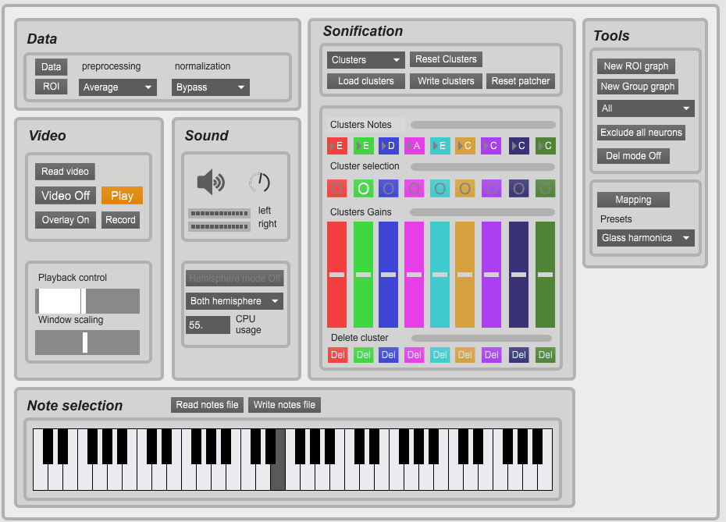Figure 1: Main Panel
This is divided into seven areas : Data, Sonification, Video, sound. Tools, driver and note selection

1) Data
This section controls the data sets for sonification.
- Read ROI file : read an ROI set processed by matlab
- read Data file : read a data file processed with matlab
- The two menus allow one to choose the normalization and preprocessing method. They are applied when selected.

2) Video
This section controls the video playback.
- The Video button (video on/off) enable or disable video processing.
- The overlay buttons displays or hide the ROIs
- When clicking record a recording of both audio and video begins. Another click ends the recording and save the file.
- Playback control

3) Sound
        - The speaker button turn on/off the sound processing.
        - The hemisphere mode turns on the hemisphere mode, in which the neurons of the right hemisphere are pitched one octave higher.
        - The hemisphere menu allows to choose which hemisphere to listen to
        - The last menu allows to listen only tracked neurons or groups
        - The knob controls the output volume.
        - The vu meters indicates the output level for the left chanel (top) and the right channel (bot)

4) Sonification control
This section controls the sonification : groups, notes, mapping, etc.
- Groups interface (fig 3) : the nine colored tracks contain the controls for the different groups. Each track contains, from top to bottom:
  - a slider to control the volume of the group
  - the note attributed to the group
  - a select button to select or deselect the group
  - a Del button to delete the group
- Clusters block
  - clusterss menu: switch between the three sets of groups
  - exclude all : remove all neurons from sonification
  - Reset Clusters : reload the default clusters over the curent groups (double click)
  - reset Patcher : return to default state
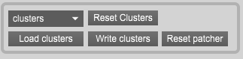Figure 2: Cluster block
  - Load/write clusters : load a cluster file or write one on disk
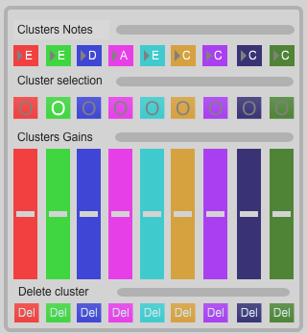Figure 3: Groups interface

5) Tools
The tools section contains the graphs and presets changes (which can also be foud in the mapping panel)
- New ROI graph : opens a new graph to monitor a single ROI
- New group graph : opens a new graph to monitor a single group.
- mapping : opens the mapping panel
- Presets menu : select which preset to use.
- Del mode : Enter deletion mode to exclude neurons from sonification
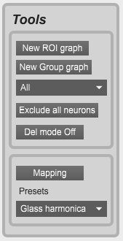Figure 4: Tools section

Mapping panel
The Mapping panel allows you to control the mapping (i.e. adjust the parameters of the data to control the parameters of the sound), the scaling functions and the parameters used. You can access it by clicking on the Mapping button on the Main panel.
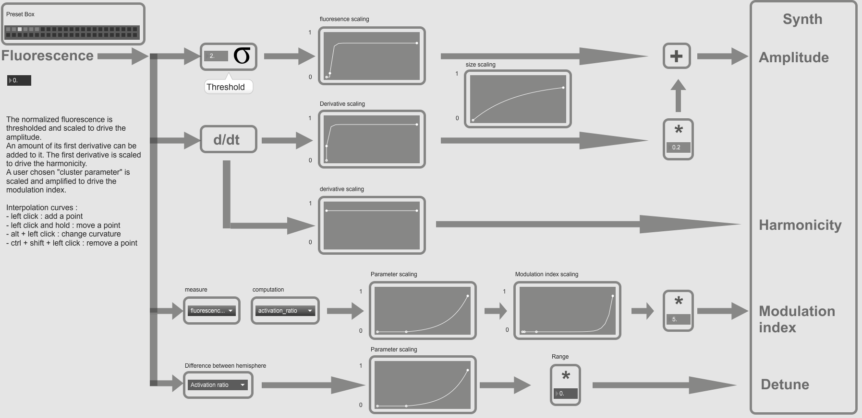Figure 5: Mapping panel
The panel is presented as a flow chart where you can follow the signal from the normalization to the synthesizer.
From top to bot you can find :
- the amplitude line
- the harmonicity line
- the modulation index line
- the detune line
We callthe incoming, processed and normalized signal.
All the curves on this panel are scaling curves which are used to scale the values. They make the coming value, the absissa, corresponds to the output value, the ordinate. All the curves are automatically saved.
- Add a point : click
- remove a point : shift + click
- change curvature : ctrl + click
- move point : hold click
- Amplitude modulation line : this line shows the mapping of each ROIs signal to the amplitude of the sound signal.
  - The normalized signal is fed to the Threshold to only conserve the activated ROIs. The incoming signalis threshed with a value corresponding to the standard deviation of the signal multiplied by a coeficient. The number box allows you to set the coeficient.
  - The outcoming signal is scaled using a scaling curve to make the activation more easily perceived.
  - The signal is then Sharpened adding its derivative (d/dt). The number box allows to change the amount of derivative added. This is to enhance the perception of events in the datas set.

- Modulation index line : this line describes the mapping to the index modulation. The normalized signal runs through it.
  - Measure menu : which value is used for computation
      - activation value : the normalized signal is used.
      - Speed value : the derivative of the normalized signal is used

  - Computation menu : what parameter is computed
      - Standard deviation : the standard deviation of the whole groups which contains the ROI is mapped.
      - Mean : the mean value over the whole group which contains the ROI is mapped.
      - Activation ratio : the ratio between the number of activated ROIs (i.e the choosen parameter is non zero) and the total number of ROIs in the group is mapped.
      - Activation ratio rate of change : the first derivative (computed over two frames) of the activation ratio is mapped.
  - The outcoming signal goes through two scaling curves.
- Detune line : this line describes the mapping to the detune effect between hemisphere. Based on the chosen parameter, neurons in the left hemisphere are pitched higher, and the ones in the right hemisphere are pitched lower.
  - Menu : select the parameter to use. The value used for synthesis is the absolute value of difference between left and right parameter.
  - Please note that the parameters are group based : the same detune will apply to each neurons in a given cluster and a given hemisphere.
- Presets : a set of parameter can be saved with shift + click on a square. Please keep in mind that an overwritten preset cannot be retrieved : overwriting a preset is permanent if the patcher is saved.

III – Interacting with the patcher
This section describes how to interact with the software : loading datasets, managing ROIs and groups, modifying the mapping and choosing different instruments.

Loading different datasets
The first thing to do is to load a dataset which consist of:
- The data to sonify
- The ROIs
- The associated video
- Cluster file (optional)
Please ensure all the loaded files have been processed with the provided Matlab script, as they need to be properly formatted to use on Max.
Procedure :
- Turn video rendering On.
- Load the video : click Load video on the Main panel. The message read_new_video: [video] 1 appears in the console.
- Load the ROIs : click Load ROI file on the Main panel. The message Read_new_ROI: bang
appears in the console
- Load the data : click Load data on the Main panel. The message Read_new_data: bang
should appear in the console.
- Choose the normalization and the processing : select the normalization and the processing to use with the normalization and processing menus on the main panel.
To load a cluster file or a group file click load cluster file or load group file on the Main panel. This should be done after loading the ROIs.

Attributing groups, notes and using clusters
Every ROIs within a group produce a sound, an ROI not allocated to a group will not produce any sound.
The different ROIs are represented by colored dots on the display, the gray ones beeing the unallocated ROIs, and the colors represent the groups.
The basic idea is that when a group is selected every group related actions (such as adding an ROI, changing the note or the color) are performed on this group. Up to nine groups can be used at the same time.
Adding an ROI to a group :
- Select the group by clicking on its select button [X] on the Sonification control section of the Main panel.
- Click on the grey filled circles you wish to assign to a group on the video. You should see the grey circles the color of you selected group.

Removing an ROI from a group :
- Enter Del mode clicking on the Del mode button on the Main panel.
- Click on the dot to remove from a group on the video.

Setting a note for a group :
- Select the group by clicking on its select button on the Main panel.
- Click on the note on the piano on the Main panel.
You can save and load sets of notes with the Write notes and Read notes buttons on the Main panel.

Monitoring signal :
- Click the new ROI/group Graphs button on the Main panel.
- Click the Set button and click on the ROI on the video, or select the group in the menu
You can pause/unpause the writing clicking on the on/off button.
Using clusters :
- Load the clusters : click Load cluster file on the Main panel.
When using cluster groups the groups you made are not overwritten, thus you can freely switch from one to another.

Modifying the mapping
You can modify the mapping using the Mapping panel. All the actions described on this part take place on this panel. All the scaling curves are sent to the synthesis when the user click on them. The dot buttons allows you to switch between curves, but keep in mind only the one corresponding to the rightmost dot will be saved in a preset.

1) Mapping to the modulation index
On the top line of the flow chart you can change the mapping to the modulation index. This parameter of the FM synthesis is what makes a brighter, trumpet like sound. The default mapping is the mean speed of the whole group.
The two menu in the Modulation index mapping section allow you to select which parameter of the data set will drive the modulation index, and thus will have an effect of the outcoming sound.
The two scaling curves describe the relation between the chosen parameter and the modulation index and can be used , they make an input value correspond to an output value.
- The first curve scales the choosen parameter : it can be used as a threshold setting the curve at zero until a certain value, enhance the higher values or the lower values, or disable the parameter from going above a certain value.
- The second curve controles the scaling of the modulation index, it makes the scaled parameter value corresponds to a modulation index value.

2) Mapping to the amplitude
The value of the signal of the ROI is used to control the amplitude, thus the loudness of the outcoming sound. The signal goes through a discrimination, a sharpening and a scaling curve.
The threshold sets the values to 0 when the signal is under a threshold value. This threshold is the standard deviation of the ROI’s multiplied by a coefficient, set with the number box. The purpose is to exclude remaining noise and keep only the active part of the signal, when the ROI is considered active.
The outcoming signal is scaled using another scaling curve which is to also enhance the perception of the activation by obtaining a more « clicky » sound. Having a great value close to zero will result in increasing the variation in the sound, whereas a low value would smooth the transition.
The sharpening consists of adding its speed (first derivative) to the signal. It is used to enhance the perception of the moment when the ROI gets active by increasing the variations. The speed is scaled by the curve below. The number box is the amount of speed added to the signal.

III – Troobleshooting
First of all, if you have any sound issue please check your audio driver is up to date and your hardware is working fine. The patcher is CPU intensive, thus it is recommended to close any other application.

1) Sound issues
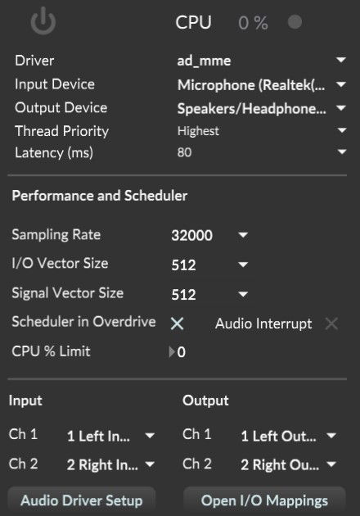Figure 6: Audio status
Bad sound, crackling sound
- Check the CPU usage from the audio status
  - go to option>audio status
  - check the CPU usage
  - if the cpu is at 100 %, decrease the sampling rate and increase both I/O vectors and signal vector size
- Try different Drivers and repeat the process if the problem is not solved
- If the problem persists and the cpu hits 100 % load, you can unselect some ROIs to reduce the amount of audio processing.

No sound
- Check whether audio is ON: the DSP button on the Main panel must be highlighted.
- In the audio status, check whether the correct output Device (i.e. the output of your computer or sound card) is selected.
- Check whether ROIs are allocated to groups : an unallocated ROI will not produce any sound.
- Check whether your data has been loaded : the message « Read_new_data» should have appeared in the console.
- Check whether the data has been processed : based on the selected normalization and treatment two messages should have appeared in the console, if they have not, relaunch the normalization or restart Max (especially for the running average) :
  - normalized_by_[method]
  - [method]_preprocessed

Some Rois do not produce sound
- Reload the ROI set.
- Lower the standard deviation coefficient in the Mapping panel.
- Move the scaling curve on the top line of the Mapping panel to the right.

2) Video issues
No video
- Make sure the video rendering is enabled : the video rendering button on the Main panel have to be highlighted.
- Check the video was successfully loaded. The message « read [video name] 1 » should have appeared in the console.

Strange ROI placement
- Reload the video.
- Reload the ROIs.

Slow video/bad synchronisation between video and sound
- Go to option>audio status.
- Turn down Sampling rate.
- Enable Scheduler in Overdrive

3) Known issues
- Overlay will not appear/no data are loaded on startup :
  - click reset patcher

https://github.com/DylanMuir/ReadImageJROI

